**Electric Charges and Fields**

***Topic:- 14-******Gauss’s law. 15-******Application of Gauss's law.***

**GAUSS’S THEOREM**

**Gauss’s theorem**

This theorem gives a relationship between the total flux passing through any closed surface and the net charge enclosed within the surface.

***Gauss theorem*** *states that the total flux through a closed surface is times the net charge enclosed by the closed surface.*

Mathematically, it can be expressed as

=

=

Or = =

For simplicity, we prove Gauss’s theorem for an ***isolated positive point charge*** *q.* As shown in figure, suppose the surface *S* is a sphere of radius *r* centre on *q*. then surface *S* is a Gaussian surface.

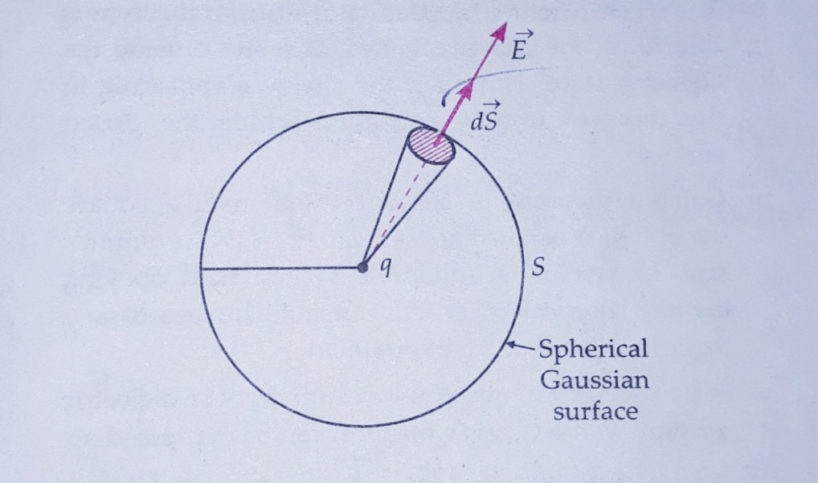

Flux through a sphere enclosed a point charge.

Electric field at any point on *S* is

*E = .*

This field point radially outward at all point on *S.* Also, any area element point radially outward, so it is parallel to, i.e., = Flux through area is

d =. =*EdScos02* = *EdS*

Total flux through surface *S* is

= = = *E*

= *E* Total area of the sphere

= . . 4

Or =

**This proves Gauss’s theorem**

**GAUSSIAN SURFACE**

*Any hypothetical closed surface enclosing a charge is called the Gaussian surface of the charge.* It is chosen to evaluate the surface integral of the electric field produced by the charge enclosed by it, which in turn gives the total flux through the surface.

**Importance**

By a clever chose of Gaussian surface. We can easily find the electric field produced by certain symmetric charge configurations which are otherwise quite difficult to evaluate by the direct application of Coulomb’s law and the principle of superposition.

**COULOMB’S LAW FROM GAUSS’S THEOREM**

**Deduction of coulomb’s law from Gauss’s theorem**

As shown in figure, consider an ***isolated positive point charge*** *q*. We select a spherical surface *S* of radius *r* centered at charge *q* as the Gaussian surface.

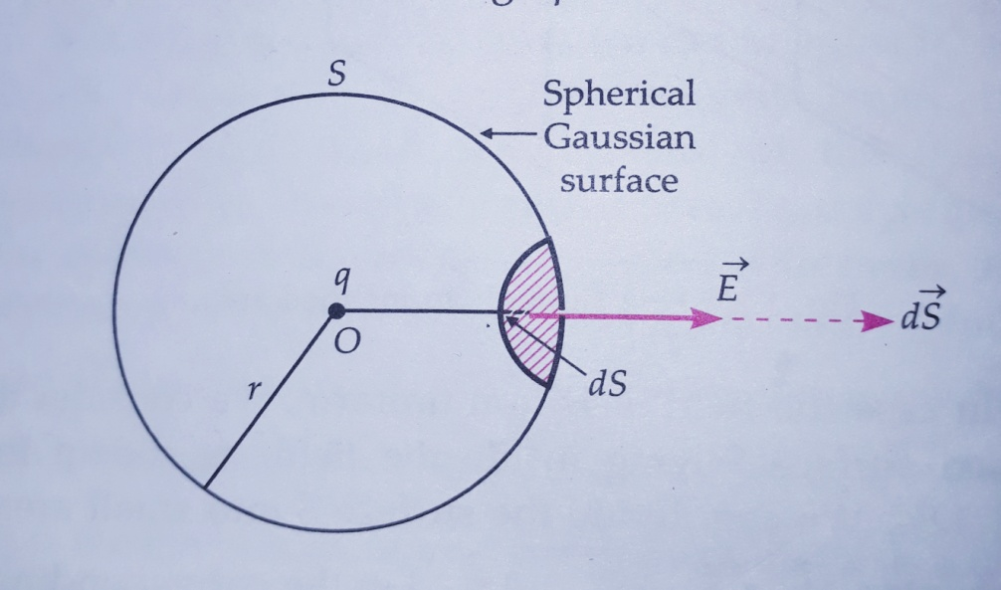

Applying gauss’s theorem to a point charge.

By symmetry has same magnitude at all points on *S*. Also and at any point on *S* are directed radially outward. Hence flux through area is

= . = *EdSCos00 = EdS*

Net flux through closed surface s is

=

=

= *E*

= *E* Total surface area of *S = E 4*

Using Gauss’s theorem,

=

Or *E 4* =

Or *E =*

The force on the point charge *q0*  if placed on surface *S* will be.

F = *qo =*   .

This proves the Coulomb’s law.

**FIELD DUE TO AN INFINITELY LONG CHARGED WIRE**

**Electric field due to an infinitely long straight charged wire**

Consider a thin infinitely long straight wire having a uniform liner charge density λCm-1. By symmetry, the field of the line charge is directed radially outward and its magnitude is same at all point equidistant from the line charge. To determine the field at a distance *r* from the charge, we choose a cylindrical Gaussian surface of *r,* length *l*, and with its axis along the line charge. As shown in figure, it has curved surface *S1* and flat circular end *S2* and *S3*. Obviously, ǀǀ , , So only the curved surface contributes toward the total flux.

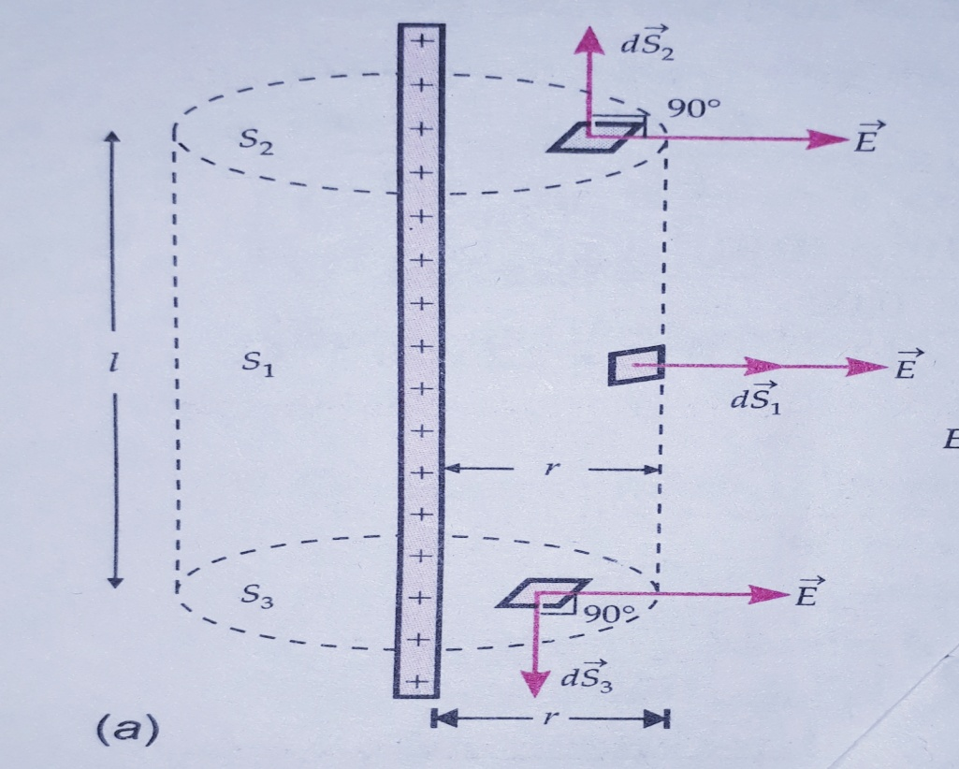

(a) Cylindrical Gaussian surface for the charge.

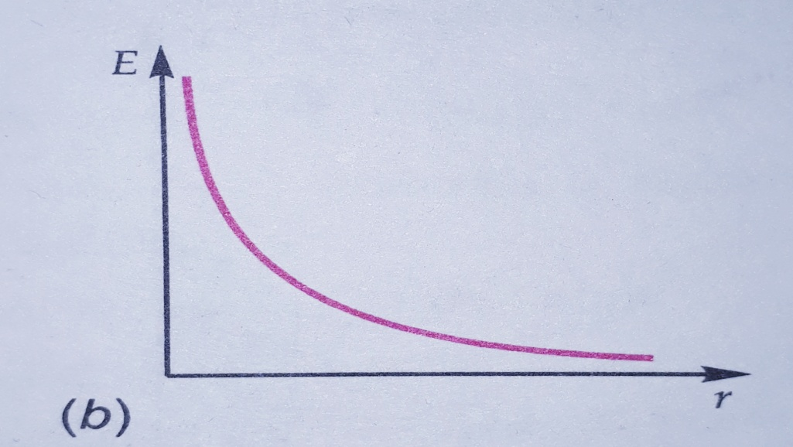

(b) Graph of E VS r.

=

=+

= +

=*E* + 0 + 0

= *E* + area of the curved surface

Or = *E* 2

Charge enclosed by the Gaussian surface,

*q = λl*

Using Gauss’s theorem

, we get

Or *E* 2 =

Or  *E =*

*Thus the electric field of a line charge is inversely proportional to the distance from the line charge.* Figure (b) shows the variation of *E* with distance *r* from the line charge.

Vectorially,  *=*

Where is the radial unit vector in plane normal to the wire passing through the observation point.

**Application of Gauss's law.**

Electric field due to a uniformly charged infinite plane sheet

As shown in figure, consider a thin infinite plane sheet of charge with uniform surface charge density. We wish to calculate its electric field at a point *P* at distance *r* from it.

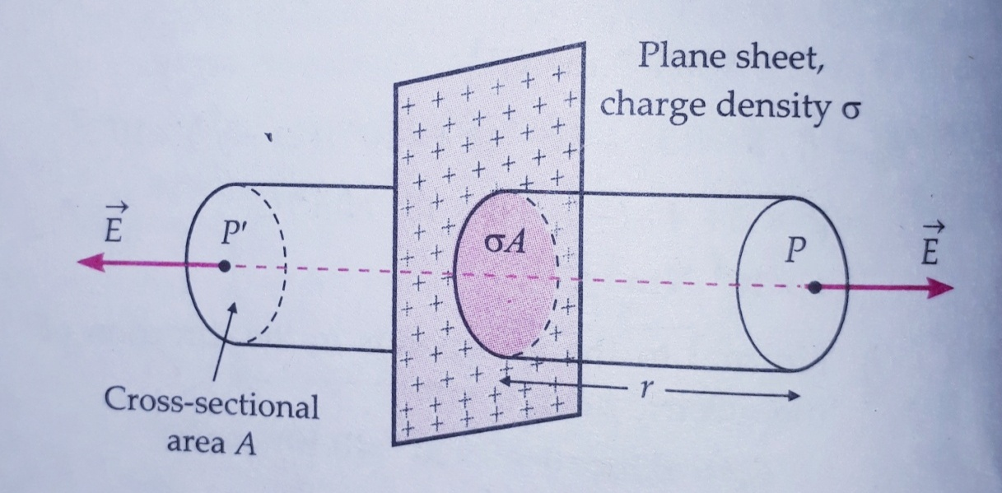

Gaussian surface for a uniformly charged infinite plane sheet.

By symmetry, electric field *E* points outwards normal to the sheet. Also, it must have same magnitude and opposite direction at two points *P* and *Pi* equidistance from the sheet and on opposite sides. We choose cylindrical Gaussian surface of cross sectional area *A* and length *2r* with its axis perpendicular to the sheet.

As the lines of force are parallel to the curved surface of the cylinder the flux through the curved surface is zero. The flux through the plane end faces of the cylinder is

= *EA + EA*

*= 2EA*

Charge enclosed by the Gaussian surface,

*q =*

According to gauss’s law,

=

*2EA =*

*Or E =*

Vectorially, =

Where is the unit vector normal to the plane and going away from it.

Clearly, E is independent of r, the distance from the plane sheet.

1-If the sheet is positively charged (σ>0), the field is directed **away** from it.

2-If the sheet is negatively charged (σ<0), the field is directed **towards** it.

For a finite large planer sheet, the above formula will be approximately valid in the middle region of the sheet, away from its edges.

**Electric field of two positively charged parallel plates.**

In given figure shows two thin plane sheets of charges having uniform charge density and with. Suppose is a unit vector pointing from left to right.

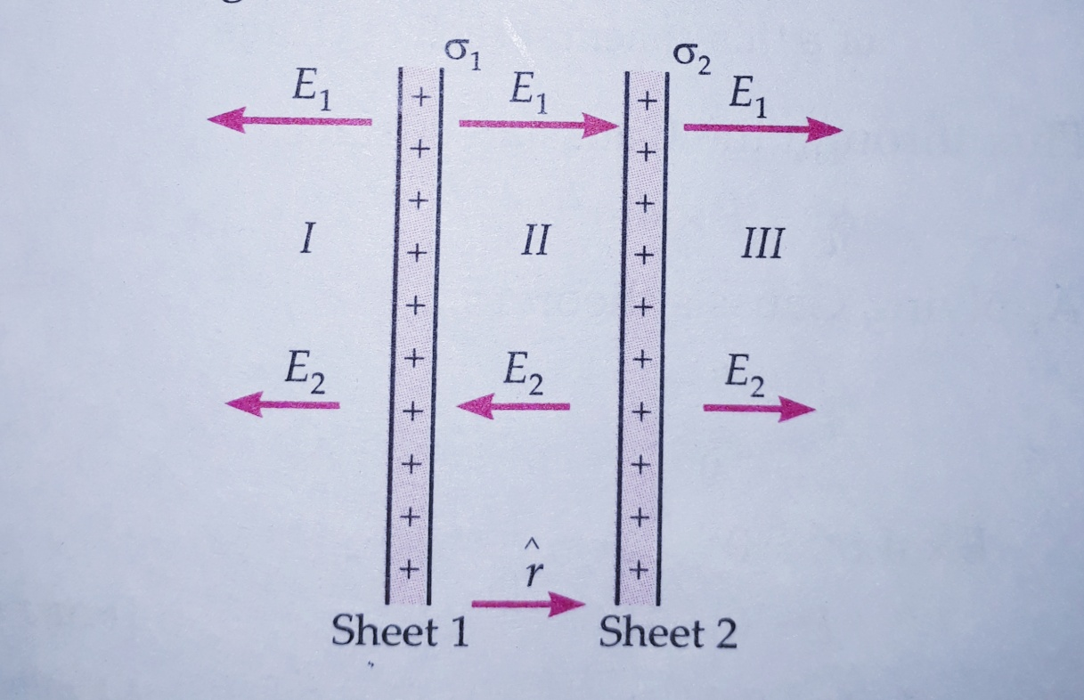

Two positively charged parallel plates

**In the region 1**:

Field due to the two sheets are

= -

= -

From the principle of superposition the total electric field at any point of region *I* is

= +

= - ( )

**In the region 2**:

Field due to the two sheets are

=

= -

Total electric field, = ( )

**In the region 3**:

Field due to the two sheets is

=

=

Total electric field, = ( )

In given figure, consider two plane parallel sheets having uniform surface charge densities of ± σ. Suppose be a unit vector pointing from left to right.

Two opposite charged plane parallel plates

**In the region 1**:

Field due to the two sheets is

= - σ

= σ

Total electric field, = +

= - =0

**In the region 2**:

Field due to the two sheets is

= σ

= σ

Total field, = +

=

=

**In the region 3**:

Field due to the two sheets is

= σ

= - σ

Total electric field, = +

=

= 0

Thus the electric field between two oppositely charged plates of equal charge density is uniform which is equal to and is directed from the positive to the negative plate, while the field is zero on the outside of the two sheets. This arrangement is used for producing ***uniform*** ***electric field.***

**FIELD DUE TO A UNIFORMLY CHARGED THIN SPHERICAL SHELL**

Consider a thin spherical shell of charge of radius *R* with uniform surface charge density *σ* from symmetry, we see that the electric field at any point is radial and has same magnitude at points equidistant from the centre of the shell i.e., the field is ***spherically symmetric****.* To determine electric field at any point *p* at a distance *r* from *O*, we choose a concentric sphere of radius *r* as the Gaussian surface.

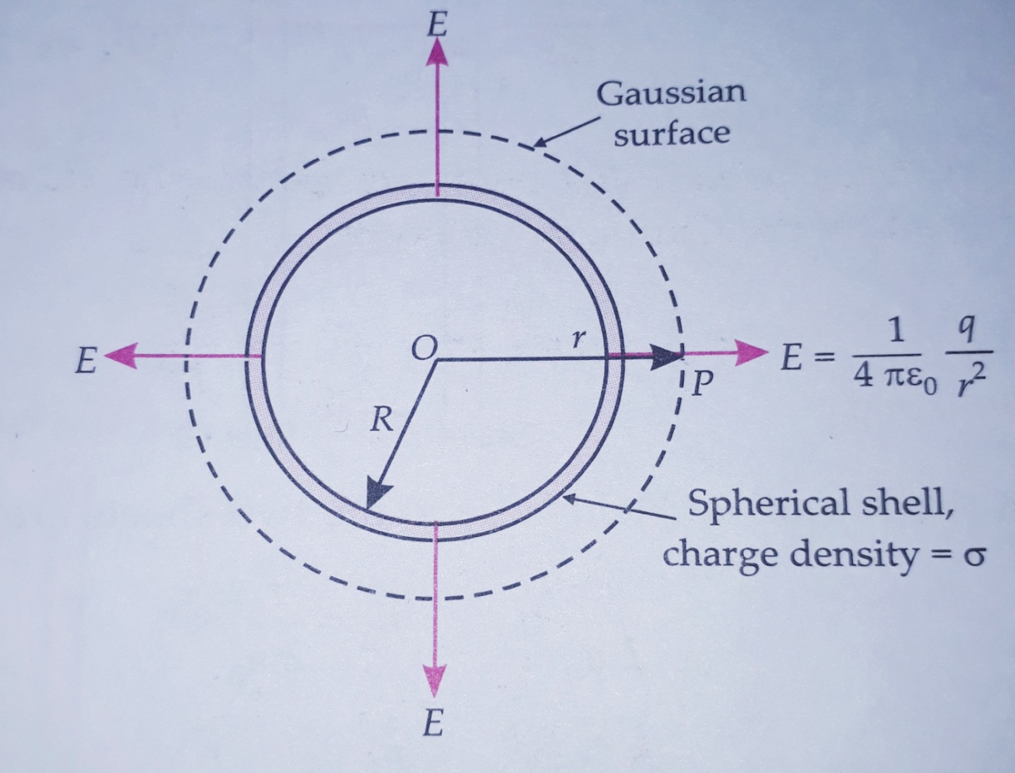

Gaussian surface for outside point of a thin spherical shell of charge.

(a) *When point P lies outside the spherical shell*. The total charge q inside the Gaussian surface is the charge on the radius *R* and area *4*.

q = 4R2σ

Flux through the Gaussian surface,

= E

By gauss’s theorem,

=

*E=*

Or *E =*

Vectorially, =

This field is the same as that produced by a charge *q* placed at the centre *O*. Hence *for point outside the shell, the field due to a uniformly charged shell is as if the entire charge of the shell of the shell is concentrated at the centre.*

*(b) When point p lies on the spherical shell.* The Gaussian surface just enclosed the charge spherical shell.

Applying gauss’s theorem,

*E=*

Or *E =*

Or E =

*(c) When point p lies inside the spherical shell.* As is clear from given figure, (a) the charge enclosed by the Gaussian surface is zero i.e.,

*q = 0*

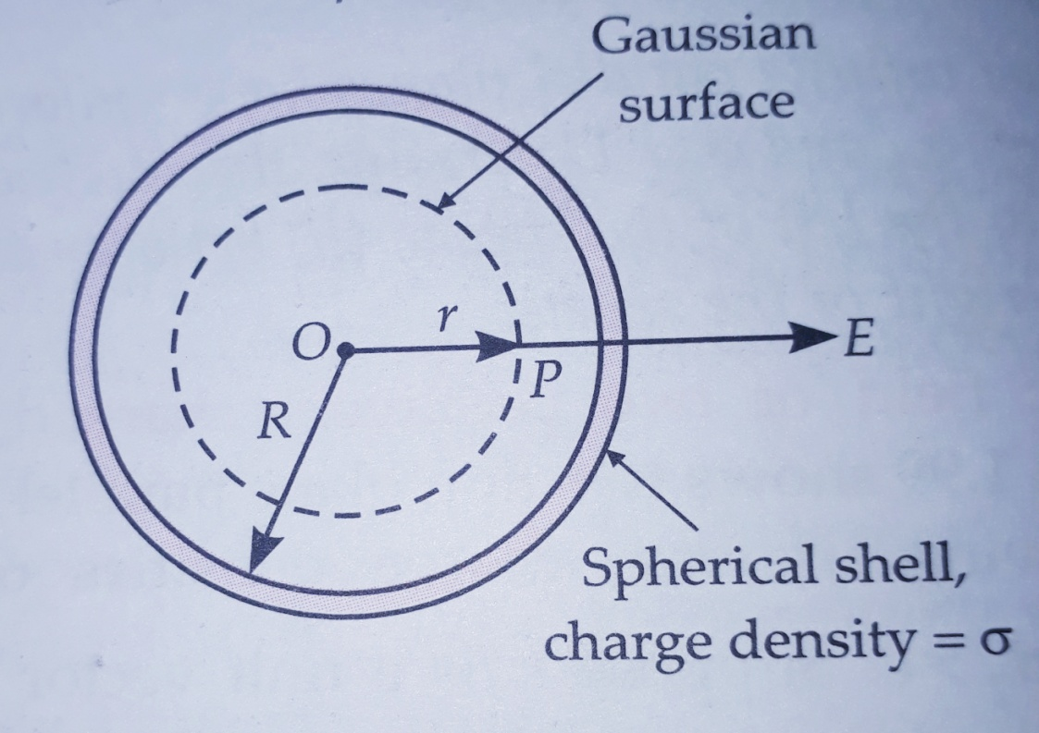

1. Gaussian surface for inside points of a thin spherical shell of charge.

Flux through the Gaussian surface,

*= E 4*

Applying gauss’s theorem,

=

*E 4 = 0*

Or  *E = 0*

*Hence electric field due to a uniformly charge spherical shell is zero at all point inside the shell.*

In given figure (b) shows how *E* varies with distance *r* from the centre of the shell of radius *R, E* is zero from r= o to r=R and beyond r= R, we have,

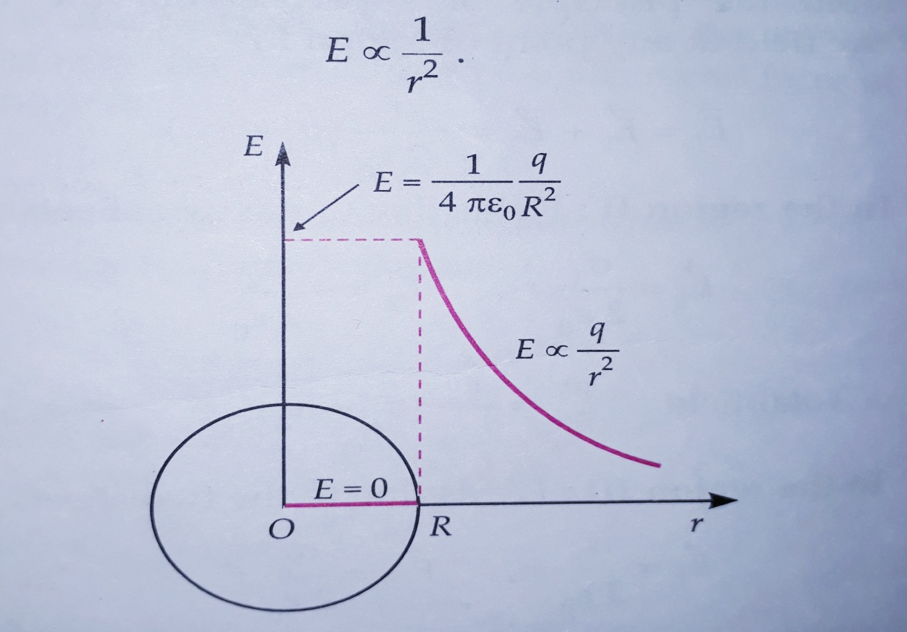

(b) Variation of E with r for a spherical shell of charge.

**Application of Gauss's law.**

ELECTRIC FIELD DUE TO A UNIFORMLY CHARGED INSULATING SPHERE

Consider an insulating sphere (for example, a nucleus with a protons almost uniform distributed inside it) of radius *A* with uniform volume charge density *ρ*. From symmetry, we see that the electric field at any point is radial and has same magnitude at point equidistant from the centre *O* of the sphere I.e., the field is ***spherically symmetric****.* To determine electric field at any point *P* at distance *r* from *O,* we choose a concentric sphere of radius *r* as the Gaussian surface.

1. *When point P lies outside the sphere.* The total charge *q* inside the Gaussian surface is the charge inside the Gaussian surface is the charge inside the sphere the radius *r.*

q =

Flux through the Gaussian surface,

= *E 4r2*

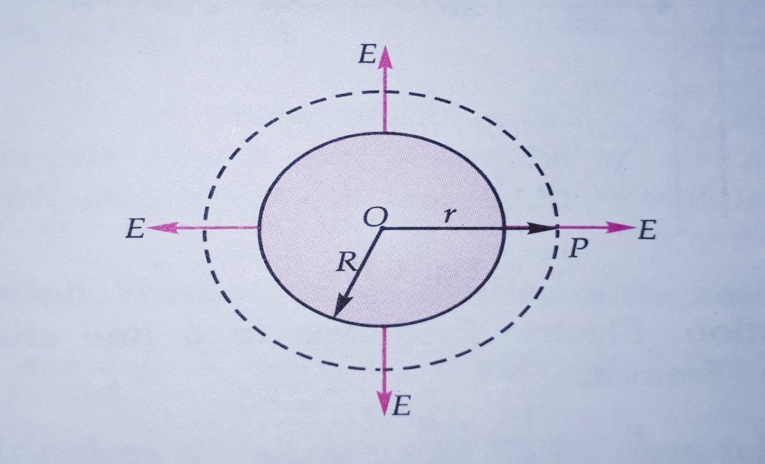

1. Gaussian surface for outside points of an insulating sphere of charge.

By gauss’s theorem,

=

*E 4 =*

*Or E =*

*Vectorially, =*

This field is same as that produced by a charge *q* placed at the centre *O.* Hence *for point outside the sphere the field due to the uniformly charged sphere is as if the entire charge of the sphere is concentrated at its centre.*

*(b) When the point P lies on the sphere*. The Gaussian surface just enclosed the charge sphere*.* Applying gauss’s theorem*.*

*E 4 =*

*Or E =*

(C) *When point P lies inside the sphere.* The charge enclosed by the Gaussian surface is

*q’ =ρ*

*q’ =*

*q’ =*

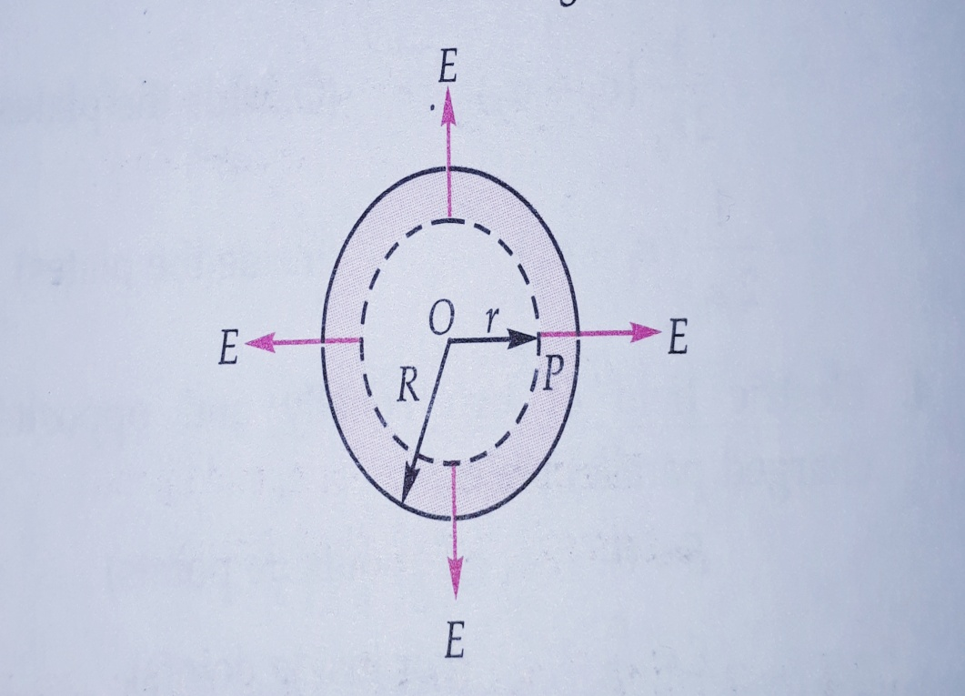

*.*  Gaussian surface for inside points of an insulating sphere of charge

By gauss’s theorem,

*E 4 =*

Or  *E 4 =*

Or  *E =*

*E =*

At the centre, *r= 0* and hence *E= 0.* The variation of *E* with distance *r* from the centre of a sphere of uniform charged sphere is shown in given figure (c).

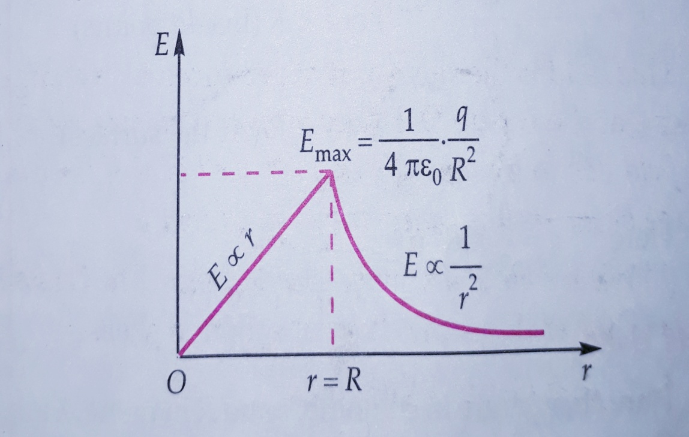

. (c) Variation of *E* with *r* for a uniform charged sphere.

…………………………………………………………………………………………………………………………………………………………………………………………………………………………………………………………………………………………………………

**PROBLEM’S**

Question1. The electric charge of any body is actually a surplus or deficit of electron. Why not proton? Solution. Electron are loosely bound to atoms and can be readily exchanged during rubbing, Protons are firmly bound inside the nucleus. They cannot be easily detached. Hence electric charge of any body is just a surplus or deficit of electron and not protons.

Question2. When a glass rod is rubbed with silk, both acquire charges. What is the source of their electrification? Solution. For the electrification of a body, only electrons are responsible. During rubbing electrons are transferred from glass rod to silk. The glass rod acquires a positive charge and silk acquires an equal amount of negative charge.

Question3. Is the mass of a body affected on charging? Solution. Yes. Electrons have a definite mass. The mass of a body slightly increases if it gains electrons while the mass decreases if the body loses electrons.

Questions4. Two identical metallic spheres of exactly equal masses are taken. One is given a positive charge *q* coulombs and other an equal negative charge. Are their masses after charging equal? Solution. No. the positive charge of a body is due to deficit of electrons while the negative charge is due to surplus of electrons. Hence the mass of the negatively charged sphere will be slightly more than that of the positively charged spheres.

Question5. A positively charged rod repels a suspended object. Can we conclude that the object is positively charged? Solution. Yes. The object is positively charged. Repulsion is the surest of electrification.

Question6. A positively charged rod attracts a suspended object. Can we conclude that the object is negatively charged? Solution. No. A positively charged rod can attract both a neutral object and a less positively charged object.

Question7. How does a positively charged glass rod attract a neutral piece of paper? Solution. The positively charged rod induces negative charge on the closer end and positive charge on the further end of the paper. The rod exerts greater attraction than repulsion on the paper because negative charge is closer to the rod than the positive charge. Hence the rod attracts the piece of paper.

Question8. Can two like charges attract each other? If yes, how? Solution. Yes. If one charge is larger than the other, the larger charge induces equal and opposite charge on the nearer end of the body with smaller charge. The opposite induced charge is larger than the small charge initially present on it.

Question9. Why do the gramophone records get covered with dust easily? Solution. The gramophone record gets charged due to the rubbing action of the needle. So they attract the dust particles from the air.

Question10. An ebonite rod held in hand can be charged be rubbing with flannel but copper rod cannot be charged like this. Why? Solution. Ebonite rod is insulating. Whatever charge appears on it due to rubbing, stays on it. Copper is good conductor. Any charge developed on it flows to the earth through our body. So copper rod cannot be charged like this. It can be charged by providing it in a plastic or rubber handle.